**ASSIGNMENT-4**

**DISTANCE DETECTION USING ULTRASONIC**

**SENSOR**

|  |  |
| --- | --- |
| Date | 27 October 2022 |
| Team ID | PNT2022TMID16918 |
| Name | Lokesh R |
| Student Roll Number | 92172019102067 |
| Maximum Marks | 2 Marks |

Question1 :

Write code and connections in wokwi for ultrasonic sensor. Whenever distance is less than 100 cms send "alert" to ibm cloud and display in device recent events.

WOKWI LINK :

<https://wokwi.com/projects/346577411886809683>

CODE :

#include <WiFi.h> //library for wifi

#include <PubSubClient.h>//library for MQtt

void callback(char* subscribetopic, byte* payload, unsigned int payloadLength);

//-------credentials of IBM Accounts--------

#define ORG "4hn0jp"//IBM ORGANITION ID

#define DEVICE_TYPE "ULTRASON" //Device type mentioned in ibm watson IOT Platform

#define DEVICE_ID "DISTANCEDETECT"//Device ID mentioned in ibm watson IOT Platform

#define TOKEN "wuo5s7PR) ZSegVk&RX"//Token

String data3;

float dist;

//-------Customise the above values------

char server[]= ORG ".messaging.internetofthings.ibmcloud.com"; // Server Name char publishTopic[] = "iot-2/evt/Data/fmt/json"; // topic name and type of event perform and format in which data to be send

char subscribetopic[] = "iot-2/cmd/test/fmt/String"; // cmd REPRESENT command type AND COMMAND IS TEST OF FORMAT STRING

char authMethod[] = "use-token-auth"; // authentication method

char token[] = TOKEN;

char clientId[] = "d:" ORG ":" DEVICE_TYPE ":" DEVICE_ID;//client id

WiFiClient wificlient; // creating the instance for wificlient

PubSubClient client (server, 1883, callback,wificlient); //calling the predefined client id by passing parameter like server id, portand wificredential

int LED = 4;

int trig = 5;

int echo = 18;

void setup()

{

Serial.begin(115200);

pinMode(trig, OUTPUT);

pinMode(echo, INPUT);

pinMode(LED, OUTPUT);

wificonnect();

mqttconnect();

}

void loop()// Recursive Function

{

digitalWrite(trig, LOW);

digitalWrite(trig, HIGH); delayMicroseconds(10);

digitalWrite(trig, LOW);

float dur = pulseIn(echo, HIGH);

float dist = (dur* 0.0343)/2;

Serial.println(dist);

Serial.print ("Distancein cm");

PublishData(dist);

delay(1000);

if (!client.loop()) {

mqttconnect();

}

}

/*...retrieving to cloud.....

...*/

void PublishData(float dist) {

mqttconnect();//function call for connecting to ibm

/*

creating the string in in form JSon to update the data to ibm cloud

*/

String object;

if (dist <100)

{

digitalWrite(LED, HIGH); Serial.println("object is near");

object = "Near";

} else

{

digitalWrite(LED, LOW);

Serial.println("no object found");

object = "No";

}

string payload= "{\"distance\":";

payload += dist;

payload += "," "\"object\":\"";

payload += object;

payload += "\"}";

Serial.print("Sending payload: ");

Serial.println(payload);

if (client.publish(publishTopic, (char*) payload.c_str())) {

Serial.println("Publish ok"); // if it sucessfully upload data on the cloud then it will print publish ok in serial monitor or else it will print publish failed

} else {

Serial.println("Publish failed");

}

void mqttconnect() {

if (Iclient.connected()) {

Serial.print("Reconnecting client to ");

Serial.println(server);

while (!!!client.connect(clientId, authMethod, token)) {

Serial.print(".");

delay(500);

}

initManagedDevice();

Serial.println();

}

}

void wificonnect() //function defination for wificonnect

{

Serial.println();

Serial.print("Connecting to ");

WiFi.begin("Wokwi-GUEST", "", 6);//passing the wifi credentials to establish the connection

while (WiFi.status() = WL_CONNECTED) {

delay(500);

Serial.print(".");

}

Serial.println("");

Serial.println("WiFi connected");

Serial.println("IP address: ");

Serial.println(WiFi.localIP());

WiFi.begin("Wokwi-GUEST", "", 6);//passing the wifi credentials to establish the connection

while (WiFi.status() != WL_CONNECTED) {

delay(500);

Serial.print(".");

} Serial.println("");

Serial.println("WiFi connected");

Serial.println("IP address: "); 131

Serial.println(WiFi.localIP());

}

void initManagedDevice() {

if (client.subscribe(subscribetopic)) { Serial.println((subscribetopic));

Serial.println("subscribe to cmd OK");

} else { Serial.println("subscribe to cmd FAILED");

}

}

void callback(char* subscribetopic, byte* payload, unsigned int payloadLength)

{

Serial.print("callback invoked for topic: ");

Serial.println(subscribetopic);

for (int i = 0; i < payloadLength; i++) { //Serial.print((char) payload[i]);

data3 += (char)payload[i];

}

Serial.println("data: "+ data3);

// if(data3=="Near")

{ // Serial.println(data3);

//digitalwrite(LED, HIGH);

//}

// else

// {

// Serial.println(data);

// digitalWrite(LED, LOW);

// }

data3="";

}

OUTPUT :

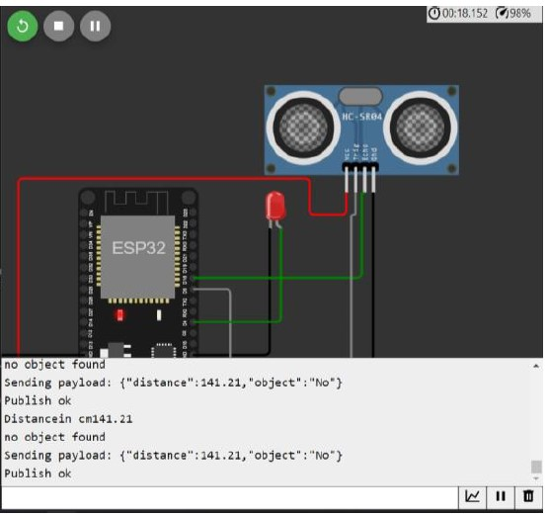

Data send to the IBM cloud device when the object is far



when object is near to the ultrasonic sensor

Data sent to the IBM Cloud Device when the object is near

